Power BI Desktop

Power BI Service (online)

Power BI Mobile

Actions that can be done:

Load the data.

Create visualizations (or charts by selecting the column names popped in the right hand side)

Now, if you want, you can transform the data. For eg: Add one more column, by duplicating the existing column, rename it, use "Standard" option to do basic math to it and click "save and close"

Now, this transformed data will get applied to existing chart. We can transform data before loading into power BI as well

Dual Axis Chart

Scatter chart

Hierarch (Category, subcategory). You can drill up and drill down to see the chart through sub-category wise.

Funnel Chart

100% stacked chart

Area Chart

Donut Chart

Card (just labels along with value)

Filters and Slicers:

Note: If a there are multiple graphical representations and bar chart, if one bar in a page is selected, rest of the graphs shows details wrt that bar. Similarly pie chart. It is all inter-related.

Filters:

It is used to select only some bars/parameters in a chart or any pictorial representation.

Slicers:

It will show the params as labels in a page so that, user can select any one/many/all params (it can also be customized) and view the chart accordingly.

Grouping and Binning:

Grouping is used to combine the existing columns and create chart whereas binning is used to create a new column (use add group icon) and create a new one and then create a chart.

Key influencers chart:

It gives AI analysed details as well.

Tree Decomposition:

Dig one level of data at a time.

PBIDS:

To save the source settings -> Option and settings -> export PBIDS

Query Editor Options:

1. Manage Parameters:

To change the source name dynamically. Available in Query Editor (Transform data) screen.

2. View:

a) Column Quality - can work on removing duplicate/empty rows.

b) column distribution - same like above but in graphical form. also represents distinct vs unique to identify primary key is perfect. eg:

distinct vs unique:

table has:

male

male

female

distinct:2 unique:1

distinct = unique means, perfect primary key

c) column profile - provides column statistics (more details) and value distribution (all the unique values in the column graphically - easy to see if we have all the values we expect is present)

Pivot/unpivot and transpose are same. But transpose does it literally with duplicates but pivot/unpivot duplicates will be numbered wisely

dimension table - contains descriptive data (products, customers, inventory) - column names are also called as attributes

Data/fact table - Contains measurable values along with key columns(sales/purchase/orders) - action - quantitative columns are also called as metrics

Options->data load -> uncheck auto detect data options

DAX:

Data analysis expressions to derive new columns from the existing column in data modelling screen.

Example:

syntax:

year = STARTOFTHEYEAR('datasourcename'[columnname])

year = STARTOFTHEYEAR('Maven Cycle Calendar'[Date])

DAX - calculations eg: year = YEAR(excelname[columnname]) -

DAX - measures (only used in fact table. can be seen as chart)

Columns (calculations) vs measures in data model:

Columns are used when you want to see the values for each calculations whereas, measures are used when you want to see the output only as a chart/visuals.

sum(columnname)

sumx(tablename, tabelname[columnname]*related(tablename[columnname]))

sumx(sales, sales[quantity_sold]*related(product[unit_price])) - >expression give profit. sumx gives aggregation or groupby category

sumx is for aggregating the output. We are using it, to get the sum of calculated values (profit).

When graphed,any y axis value chosen, this will be grouped to sum.

If averagex is used, then average profit for that category will be displayed

Calculate:

Calculate is used to activate the inactive relationship. For eg: If two dates in sales table are mapped to one date in calendar table.

Syntax:

variablename = calculate([measure], tablename[columnname](or the foreign key), tablename[columnname](or the primary key)

quantity_sold = calculate([Quantity_Sold], USERRELATIONSHIP('Maven Cycle Sales'[Stock_Date], 'Maven Cycle Calendar'[Date])

Last month revenue = calculate([Total Revenue], DATESADD('Maven Cycle Calendar'[Date], -1, MONTH))

The above syntax calculate revenue for the last one month where -1 is the interval. If its -1, it means previous. MONTH with -1 represents previous month.

All:

All function removes all the filters in the table before producing the chart.

syntax:

All profit = calculate([measure], All(tablename))

This'll remove all the filters hence, all the rows, will carry same all profit amount. That all profit amount can be used to calculate the profit margin like below:

profit margin = divide([profit], [all profit])

now for all the rows, each unique profit will be divided by all profit value

Filter:

Filter is used when you want the subset of a table to be iterated.

for eg:

mid range revenue = sumx(filter(tablename, tablename[columnname]="Mid"), [Total Revenue])

Edit Interaction - facilitates to connect or disconnect different charts on the same page based on the filter.

Bookmark - to bookmark two different setup of a chart during presentation. Like, setting up first page of filter for first 6 months and other bookmark with name reset to set up the filter page for full year

Paginated Reports:

To print whole rows in a dashboard instead of what is in the view. To do this, you need to install paginated power bi report builder. create a format which you want the data to printed and then upload it to Power bi service and try to print. Better to check the course for more details.

Charts and its purposes:

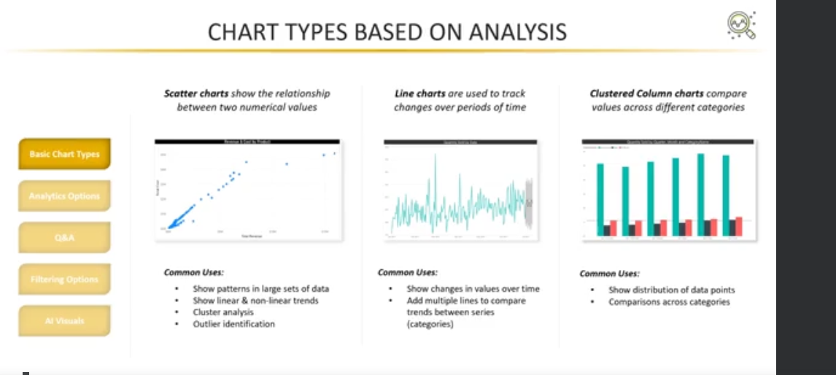

Decomposition tree:

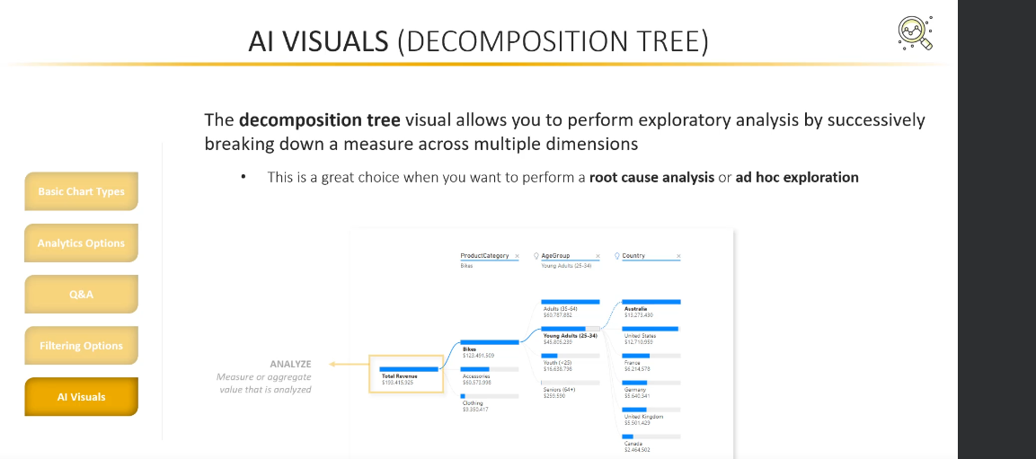

Try on Q and A optimization to train the AI model for better answers to the possible questions asked during presentation.

Grouping:

It is present by right clicking the value/column selected and placed under x axis/y axis. This is to group the texts present in x axis. For example, two different bars for north east and north west can be grouped together to one label called north.

Row level security (RLS)

Static row level security – based on any criteria like region

Dynamic RLS – based on USERNAME() OR USERPRINCIPALNAME()

USERNAME()-> domain/username

USERPRINCIPALNAME()->[username@domain.com](mailto:username@domain.com)

Note: A separate table for role and region is required for this table to work and the table should be connected to the data model.

Using Static RLS, it all the user email ids can be added to this model. But whoever is added, will have access to the region designed. For example if France is given as filter [value] = ‘FRANCE’ in desktop version.

For dynamic, all the email ids added will have access to the region corresponding to those email-ids in the table.

To avoid above all the mess, azure active directory is used for easy maintenance, good performance incase of many users.

SUBSCRIPTION:

To get subscribed to dashboard, reports etc, user must have PRO or PPU license.

Data Lineage tools:

It is to find out the errors in the flow between source, transform data/query editor, reports and dashboard.

The possible errors that can be seen are refresh failed, data not updated in dashboard etc

Incremental Refresh:

To refresh only the newly added data instead of whole billions of rows. It is applicable only in RDMS, azure active directory but not in excels or webpage

Things to read:

Power BI deployment pipeline

DAX

Dashboard models